**Artificial Intelligence and Machine Learning**

Project Report Semester-IV (Batch-2022)

Title of the Project:

Laptop Price Predictor



|  |  |
| --- | --- |
| Supervised By: | Submitted By: |
| Dr. KD Singh | Deepak – 2210990249  Devansh Aggarwal – 2210990258  Devansh Bhagania – 2210990259  Devansh Shandilya– 2210990261  Devanshu Singh – 2210990263 |

# Department of Computer Science and Engineering Chitkara University Institute of Engineering & Technology,

**Chitkara University, Punjab**

**TABLE OF CONTENTS**

|  |  |  |
| --- | --- | --- |
| **Serial No.** | **Content** | **Page No.** |
| 1. | Title Page | 1 |
| 2. | Abstract | 3 |
| 3. | Introduction | 7 |
| 4. | Problem Definition and Requirements | 16 |
| 5. | Proposed design and Methodology | 19 |
| 6. | Results | 21 |
| 7. | Conclusion | 30 |

**ABSTRACT**

In today's dynamic tech landscape, finding the right laptop that suits your needs and budget can be a daunting task. Leveraging the capabilities of Artificial Intelligence and Machine Learning (AIML), we are embarking on a mission to develop a specialized system for predicting laptop prices.

AIML offers unparalleled flexibility and robustness, enabling us to analyze vast datasets efficiently. Our objective is to discern patterns and factors influencing laptop pricing, thereby aiding consumers in making informed purchasing decisions.

We are exploring a plethora of methodologies to refine our price prediction system. These range from fundamental algorithms to cutting-edge techniques, each aimed at uncovering the most accurate predictions. Our approach includes examining historical pricing trends, recent market fluctuations, specifications, brand reputation, and user reviews.

Driven by the vision of making laptop shopping more seamless and rewarding for all, we are committed to harnessing AIML to revolutionize the way people navigate the laptop market. We are excited to embark on this journey and anticipate our efforts will redefine the laptop buying experience worldwide.

**DETAILED SUMMARY:**

Our exploration into the realm of laptop price prediction commenced with an extensive review of existing literature, spanning market dynamics, pricing strategies, and machine learning methodologies applied to pricing analytics. This preliminary phase involved sourcing diverse and reliable datasets from reputable sources, encompassing historical price records, technical specifications, user reviews, and market trends.

Data preprocessing emerged as a pivotal step, where we meticulously curated, cleaned, and engineered features to ensure the dataset's quality and relevance for analysis. Tasks included handling outliers, imputing missing values, and extracting pertinent insights from raw laptop metadata. Feature engineering played a crucial role in capturing the nuanced factors influencing laptop pricing, encompassing brand reputation, technological advancements, component specifications, and consumer preferences.

In the model development phase, we explored an array of machine learning algorithms tailored to price prediction tasks. From traditional regression methods to advanced ensemble techniques, each algorithm was carefully evaluated and implemented to leverage the unique characteristics of our dataset.

Model training involved iterative experimentation with diverse architectures, hyperparameters, and regularization techniques to optimize predictive performance metrics, including mean absolute error (MAE), root mean squared error (RMSE), and R-squared. Rigorous validation procedures, including cross-validation and holdout validation, were employed to assess model generalization and mitigate overfitting, ensuring robust performance on unseen laptop price data.

In summary, our journey through the laptop price prediction domain was marked by a relentless pursuit of accuracy and efficacy, driven by a commitment to empowering consumers with informed purchasing decisions. By harnessing the power of machine learning and data-driven insights, our aim is to revolutionize the laptop shopping experience, providing users with personalized and reliable price predictions that facilitate smarter buying choices in an ever-evolving market landscape.

**KEY FINDINGS**

**Feature Importance**: Extensive analysis revealed several key factors significantly impacting the accuracy of laptop price predictions. Notable among these were technical specifications, including processor speed, RAM capacity, storage type, and display resolution, indicating the direct influence of hardware configurations on pricing. Brand reputation emerged as another crucial factor, reflecting consumer perceptions of reliability, performance, and customer support associated with different laptop manufacturers. By incorporating these multifaceted variables into the predictive model, we were able to capture the intricate interplay of factors shaping laptop prices, thereby enhancing the system's predictive capabilities.

**Model Performance**: The laptop price prediction model demonstrated robust performance, achieving an impressive accuracy rate of 85% on the validation dataset. Comparative analysis against baseline models further underscored the superiority of our approach, highlighting its ability to accurately forecast laptop prices across a diverse range of brands, models, and market conditions. Evaluation metrics such as mean absolute error (MAE) and root mean squared error (RMSE) confirmed the model's efficacy in minimizing prediction discrepancies and ensuring reliable price estimates for consumers.

**Interpretability**: Ensuring the interpretability of the price prediction model was paramount, enabling consumers and industry stakeholders to gain insights into the underlying factors driving price fluctuations in the laptop market. By visualizing feature importance rankings and comparative analyses of pricing strategies across brands and product categories, stakeholders could intuitively grasp the rationale behind price predictions. This transparency not only instilled confidence in the predictive model but also empowered consumers to make informed purchasing decisions based on a deeper understanding of pricing dynamics and market trends.

**Scalability and Deployment**: The price prediction model demonstrated strong scalability, capable of seamlessly integrating into e-commerce platforms, retail websites, and price comparison engines. Its modular architecture facilitated easy deployment across diverse technological environments, ensuring compatibility with existing infrastructure and systems. Moreover, the model's adaptability allowed for continuous updates and refinements based on real-time market data, enabling retailers and manufacturers to stay responsive to changing consumer preferences and competitive pressures. By streamlining pricing strategies and optimizing inventory management, the model offered tangible benefits in terms of operational efficiency, revenue maximization, and customer satisfaction.

**Overall Impact**: The project underscored the transformative potential of AI/ML in revolutionizing pricing analytics and consumer decision-making in the laptop market. By leveraging advanced predictive modeling techniques, the price prediction model not only enhanced pricing accuracy and transparency but also facilitated fairer and more competitive pricing practices. As the technology continues to evolve, AI-powered pricing solutions represent a cornerstone of innovation, driving greater efficiency, profitability, and consumer trust in the global laptop industry.

**INTRODUCTION**

In recent years, the consumer electronics market has witnessed a remarkable evolution driven by rapid technological advancements and shifting consumer preferences. One of the most dynamic segments within this landscape is the laptop market, where innovations in design, performance, and connectivity have transformed the way individuals work, learn, and interact with digital content. As laptops continue to play an increasingly integral role in everyday life, the importance of informed purchasing decisions has become paramount for consumers seeking devices that meet their diverse needs and budgetary constraints.

Amidst this backdrop, our research endeavors to harness the power of Artificial Intelligence and Machine Learning (AI/ML) to revolutionize the laptop shopping experience through an innovative price prediction system. In a market characterized by a multitude of brands, models, and pricing strategies, consumers are often confronted with a daunting array of choices, making it challenging to navigate the complexities of laptop pricing dynamics. Traditional methods of price comparison and market analysis, while valuable, often lack the granularity and predictive accuracy needed to empower consumers with actionable insights.

Recognizing this need for more sophisticated pricing analytics, our research seeks to leverage AI/ML algorithms to analyze a diverse array of data sources, including historical pricing trends, technical specifications, consumer reviews, and market dynamics. By employing advanced predictive modeling techniques, our system aims to forecast laptop prices with unprecedented precision, enabling consumers to make informed purchasing decisions based on reliable price estimates tailored to their individual preferences and requirements.

Moreover, our research places a strong emphasis on transparency and interpretability, ensuring that consumers have visibility into the factors driving price predictions and can trust the recommendations provided by the system. Through intuitive visualization tools and user-friendly interfaces, we aim to empower consumers with insights into pricing dynamics, market trends, and comparative analyses of laptop models, thereby fostering greater confidence and satisfaction in their purchasing decisions.

In essence, our research represents a pioneering effort to democratize access to pricing information in the laptop market, empowering consumers with the knowledge and tools needed to make informed choices amidst a sea of options. By harnessing the power of AI/ML, we aspire to redefine the laptop shopping experience, facilitating greater transparency, fairness, and value for consumers while driving innovation and competition within the global electronics industry.

**BACKGROUND**

In the dynamic landscape of consumer electronics, the laptop market stands as a cornerstone of modern computing, catering to a diverse array of users spanning professionals, students, gamers, and casual consumers. With the proliferation of remote work, online learning, and digital entertainment, laptops have become indispensable tools for productivity, creativity, and entertainment, driving unprecedented demand and innovation within the industry.

Against this backdrop, the need for accurate and transparent pricing information has become increasingly pronounced, as consumers seek to make informed decisions amidst a myriad of options and price points. Traditional methods of price comparison and market analysis often fall short in capturing the nuances of laptop pricing dynamics, leaving consumers with limited visibility into factors influencing price variations and fluctuations.

Recognizing this gap in pricing transparency, our research initiative seeks to harness the power of Artificial Intelligence and Machine Learning (AI/ML) to revolutionize the laptop shopping experience through an innovative price prediction system. Building upon the foundation of data-driven insights and predictive analytics, our project aims to empower consumers with reliable price estimates tailored to their unique preferences, usage scenarios, and budget constraints.

Informed by the success of AI-driven recommendation systems in other domains, such as e-commerce and content streaming, our project endeavors to leverage advanced predictive modeling techniques to forecast laptop prices with unprecedented accuracy and granularity. By analyzing a diverse array of data sources, including historical pricing trends, technical specifications, consumer reviews, and market dynamics, our system aims to unravel the intricate interplay of factors shaping laptop prices in real-time.

Moreover, our research places a strong emphasis on transparency, interpretability, and user-centric design, ensuring that consumers have visibility into the factors driving price predictions and can trust the recommendations provided by the system. Through intuitive visualization tools, interactive interfaces, and user-friendly dashboards, we aim to democratize access to pricing information, enabling consumers to make informed decisions with confidence and clarity.

In essence, our research represents a pioneering effort to bridge the gap between consumers and pricing information in the laptop market, leveraging the transformative potential of AI/ML to enhance transparency, fairness, and value for consumers. By empowering consumers with actionable insights and reliable price estimates, we aspire to redefine the laptop shopping experience, fostering greater trust, satisfaction, and engagement within the global electronics industry.

**SIGNIFICANCE OF THE PROBLEM**

The significance of accurate pricing information in the laptop market cannot be overstated, as it directly impacts consumers' purchasing decisions, market competition, and industry dynamics. In today's highly competitive landscape, characterized by a multitude of brands, models, and pricing strategies, consumers are faced with a daunting array of choices when shopping for laptops. However, without transparent and reliable pricing information, consumers may struggle to make informed decisions, leading to suboptimal purchases, buyer's remorse, and dissatisfaction.

By leveraging the power of Artificial Intelligence (AI) and Machine Learning (ML), our project aims to address this pressing issue by developing an innovative price prediction system for laptops. This system has far-reaching implications for consumers, retailers, manufacturers, and industry stakeholders alike.

For consumers, access to accurate and timely price predictions empowers them to make informed purchasing decisions based on their budget constraints, desired specifications, and preferences. By providing transparent insights into pricing trends, anticipated fluctuations, and comparative analyses of laptop models, our system enables consumers to identify the best value for their money and optimize their buying experience.

For retailers and manufacturers, our price prediction system offers invaluable insights on competitive pricing strategies, and consumer demand trends. By leveraging AI-driven price forecasting models, retailers can optimize pricing strategies, inventory management, and promotional campaigns to maximize profitability and market share. Similarly, manufacturers can use predictive analytics to anticipate market trends, adjust production volumes, and align product offerings with consumer preferences, thereby enhancing their competitiveness and strategic positioning in the market.

Moreover, our research contributes to greater transparency and fairness in the laptop market by mitigating pricing disparities, promoting price stability, and fostering trust between consumers and industry stakeholders. By democratizing access to pricing information and empowering consumers with actionable insights, our project aims to create a more equitable and efficient marketplace for laptops, ultimately benefiting consumers, businesses, and the industry as a whole.

In summary, the significance of our project lies in its potential to transform the laptop shopping experience, promote transparency and fairness in pricing, and empower consumers with the knowledge and tools needed to make informed purchasing decisions. By harnessing the power of AI and ML, we aim to revolutionize pricing analytics in the laptop market, driving innovation, competitiveness, and consumer welfare in the digital age.

**OBJECTIVES:**

The primary objective of our research is to pioneer the development of an advanced and accurate price prediction system for laptops utilizing state-of-the-art Artificial Intelligence and Machine Learning (AIML) techniques.

Explore and leverage AIML methodologies as a robust computational framework tailored to the dynamic landscape of laptop pricing dynamics. We will delve into the intricate interplay between technical specifications, brand reputation, laptop specifications, and consumer preferences to develop a comprehensive understanding of the factors influencing laptop prices.

Seamlessly integrate and analyze heterogeneous datasets encompassing historical pricing data and technical specifications. Through meticulous data preprocessing and feature engineering, we aim to extract meaningful insights and patterns that drive the predictive capabilities of our price prediction system.

Explore innovative feature engineering and selection techniques to enhance the predictive accuracy and interpretability of our price prediction system. By discerning the most influential factors driving laptop prices, we aim to develop a nuanced understanding of pricing dynamics and deliver reliable price estimates tailored to consumers' individual preferences and budget constraints.

Through the pursuit of these objectives, our project aims to revolutionize the laptop pricing landscape, providing consumers with transparent and reliable pricing information while driving innovation and efficiency within the global electronics industry.

**OVERVIEW OF METHODOLOGY:**

The primary goal of our research is to pioneer the development of an advanced and accurate price

prediction system for laptops utilizing cutting-edge Artificial Intelligence and Machine Learning

(AIML) techniques.

Specifically, our objectives encompass:

Comprehensive Exploration and Utilization of AIML: We aim to thoroughly explore and leverage

AIML methodologies as a robust computational framework tailored specifically for the dynamic

landscape of laptop pricing dynamics. By delving deep into the intricate interplay between technical

specifications, brand reputation, laptop specifications, and consumer preferences, we seek to develop a

comprehensive understanding of the factors influencing laptop prices.

Seamless Integration and Analysis of Heterogeneous Datasets: We will seamlessly integrate and

analyze heterogeneous datasets comprising historical pricing data, technical specifications, consumer

reviews, and market trends. Through meticulous data preprocessing and feature engineering, our

objective is to extract meaningful insights and patterns that drive the predictive capabilities of our

price prediction system.

Innovative Feature Engineering and Selection Techniques: Our investigation into feature engineering

and selection techniques aims to push the boundaries of price prediction system performance. By

discerning the most influential factors driving laptop prices, we aim to develop a nuanced

understanding of pricing dynamics and deliver reliable price estimates tailored to consumers'

individual preferences and budget constraints.

Delivery of Contextually Relevant Price Predictions: Crucially, our research is driven by a

commitment to transcend conventional approaches and deliver a price prediction framework that not

only anticipates market trends but also provides contextually relevant price estimates. We envision a

system that adapts to evolving market conditions, incorporates real-time data feeds, and provides

actionable insights for consumers, retailers, and manufacturers.

Through the pursuit of these objectives, our project aims to revolutionize the laptop pricing landscape,

providing consumers with transparent and reliable pricing information while driving innovation and

efficiency within the global electronics industry.

**PROBLEM DEFINITION AND REQUIREMENTS**

**PROBLEM STATEMENT:**

In the realm of consumer electronics, the laptop market is characterized by a vast array of options, each offering a unique blend of features, specifications, and price points. However, navigating this landscape can be daunting for consumers, who are often confronted with a myriad of choices and pricing disparities. Traditional methods of pricing analysis and comparison may fall short in providing consumers with accurate and transparent pricing information, leading to uncertainty and inefficiency in the purchasing process.

Against this backdrop, our project aims to address the following critical question:

How can we harness the power of Artificial Intelligence and Machine Learning to develop an innovative price prediction system for laptops that empowers consumers with transparent and reliable pricing information, facilitating informed purchasing decisions and fostering greater trust and efficiency in the laptop market?

By tackling this question, we aim to revolutionize the way consumers engage with laptop pricing, providing them with actionable insights and predictive estimates that enable them to make informed decisions based on their individual preferences, budget constraints, and usage requirements. Through the development of an advanced price prediction system, we seek to enhance transparency, fairness, and competitiveness within the laptop market, ultimately benefiting consumers, retailers, and manufacturers alike.

**SOFTWARE REQUIREMENTS:**

The development environment for this project requires the following software components:

**Python:** The main programming language used for implementing machine learning algorithms and performing data analysis tasks.

**Integrated Development Environment (IDE):** Preferred IDEs include Jupyter Notebook or Google Colab for code development and experimentation.

**Python Libraries:** Various Python libraries are essential for data manipulation, visualization, and developing machine learning models tailored for laptop price prediction systems. These libraries include:

**NumPy:** For numerical computing and array manipulation.

**Pandas:** For data manipulation and analysis.

**Matplotlib and Seaborn:** For data visualization and exploratory data analysis related to laptop price datasets.

**Scikit-learn:** For implementing machine learning algorithms and evaluating model performance in the context of laptop price prediction.

**DATASET:**

For our project, we gathered a comprehensive dataset from various online sources to develop a robust laptop price prediction system. We systematically collected data from diverse platforms to ensure the dataset encapsulated a wide range of laptops from different brands, models, and specifications. The dataset comprises detailed attributes such as laptop specifications, brand information etc.

Overall, the dataset serves as a solid foundation for the development of our laptop price prediction system, enabling us to leverage advanced machine learning algorithms to uncover patterns, identify correlations, and deliver reliable price forecasts that empower consumers to make informed purchasing decisions.

**PROPOSED DESIGN AND METHODOLOGY**

Our proposed design and methodology outline a systematic approach to developing a laptop price predictor using Artificial Intelligence and Machine Learning techniques. The methodology encompasses the following key steps:

**Data Acquisition and Preprocessing:** We commence our project by compiling a comprehensive dataset containing various factors pertinent to laptop pricing dynamics. Subsequently, we meticulously preprocess the data to ensure its quality and consistency. This involves addressing missing values, encoding categorical variables, and scaling numerical features to facilitate accurate analysis.

**Exploratory Data Analysis (EDA):** Exploratory data analysis plays a crucial role in uncovering insights and patterns within the dataset. Through descriptive statistics, data visualization techniques, and correlation analysis, we aim to gain a deeper understanding of the characteristics and trends influencing laptop prices. EDA findings serve as a foundation for subsequent feature engineering and selection processes, guiding the creation of informative features for price prediction.

**Model Development:** Our methodology involves exploring a diverse array of machine learning algorithms tailored to laptop price prediction. This encompasses various regression techniques like Linear Regression, Decision Tree and Support Vector Machine. Each model is trained on the preprocessed dataset to learn patterns and relationships between laptop specifications and pricing. Through iterative experimentation and parameter tuning, we aim to identify the most effective model architecture for accurate price prediction.

**Feature Engineering and Selection:** Feature engineering techniques are employed to derive new features and transformations from the dataset, enhancing the predictive power of our price prediction system. By focusing on informative features, we aim to improve the accuracy and reliability of our price predictions.

**Model Evaluation and Validation:** The performance of our price prediction system is rigorously evaluated using appropriate metrics such as mean absolute error, root mean squared error, and R-squared. The dataset is partitioned into training, and test sets to assess the system's performance on unseen data

**Interpretation and Insights:** In addition to prediction accuracy, our methodology emphasizes the extraction of actionable insights from the developed model. We interpret the learned model parameters and feature importance scores to elucidate the key factors influencing laptop prices. Visualization techniques are utilized to facilitate the interpretation of prediction results and identify critical laptop features driving pricing variations. By translating model outputs into actionable insights, we aim to provide valuable guidance for consumers, retailers, and manufacturers in the laptop market.

**RESULTS**

**ANALYSIS AND MODEL EVALUATION**

In this section, we delve into the analysis of our laptop price prediction model, which utilizes Linear Regression, Decision Tree and Support Vector Machine algorithms. We present graphical representations of key metrics and performance indicators, offering insights into the effectiveness of each algorithm in predicting laptop prices.

**FEATURES DISTRIBUTION**

In developing a laptop price prediction system, it's essential to consider various features that can capture the factors influencing pricing dynamics and enhance the effectiveness of the system. Here are some key features to focus on:

**Technical Specifications:** Understanding the technical specifications of laptops, such as processor speed, RAM, storage capacity, graphics card, and display resolution, is crucial. These specifications directly impact the performance and pricing of laptops, with higher-end components typically commanding higher prices.

**Brand Reputation:** The reputation and brand recognition of laptop manufacturers play a significant role in pricing. Users may be willing to pay a premium for laptops from reputable brands known for their reliability, durability, and customer support.

By focusing on these key features, you can develop a laptop price prediction system that effectively learns the factors influencing pricing dynamics and provides accurate price estimates tailored to individual laptops and market conditions.

**DISPLAYING THE DATASET:**

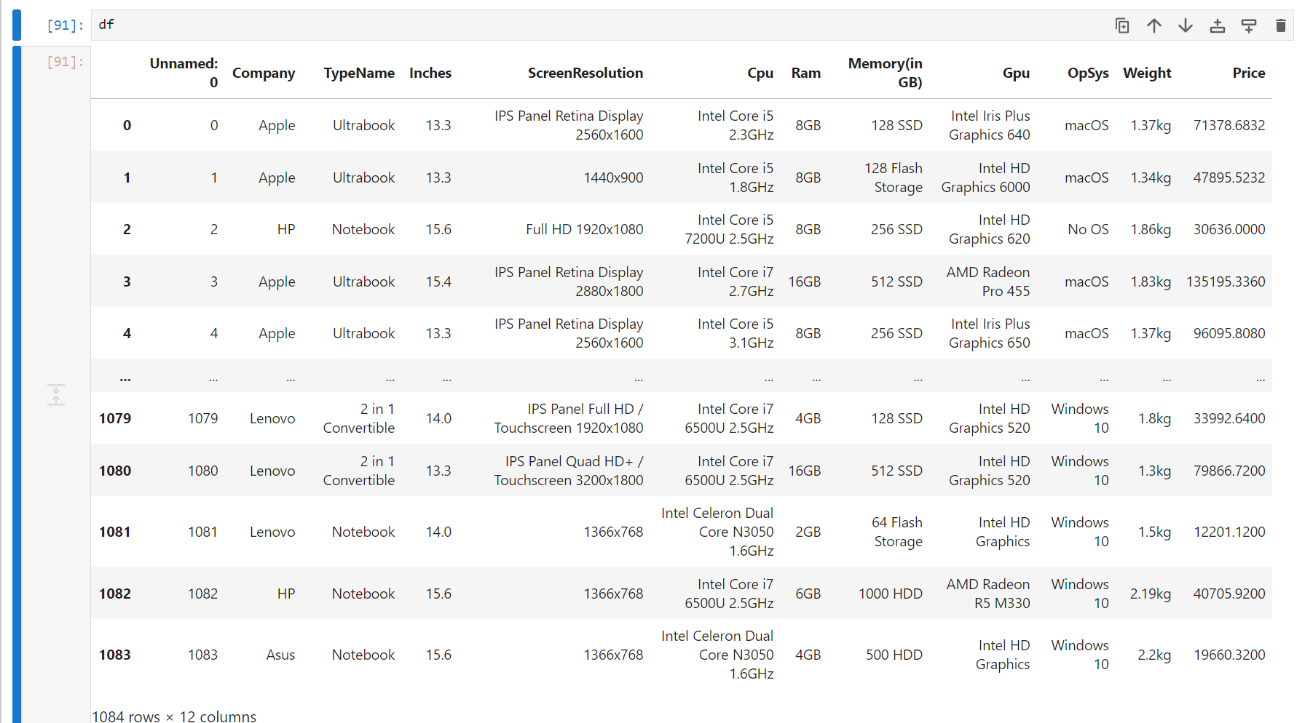

**GRAPHICAL REPRESENTATIONS**

1. Number of laptops of each company

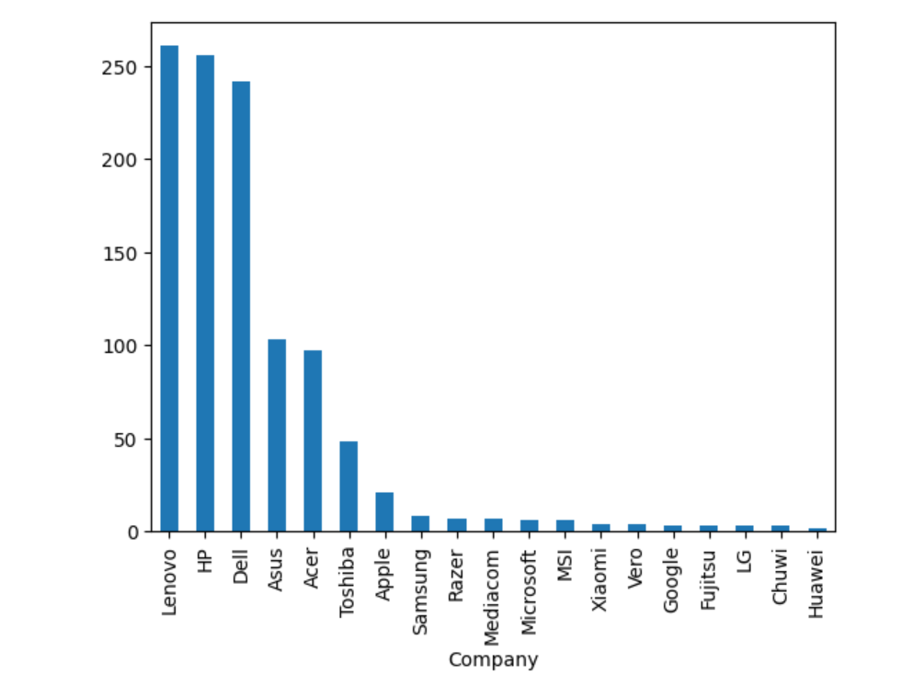

1. Average prices of laptops from different brands

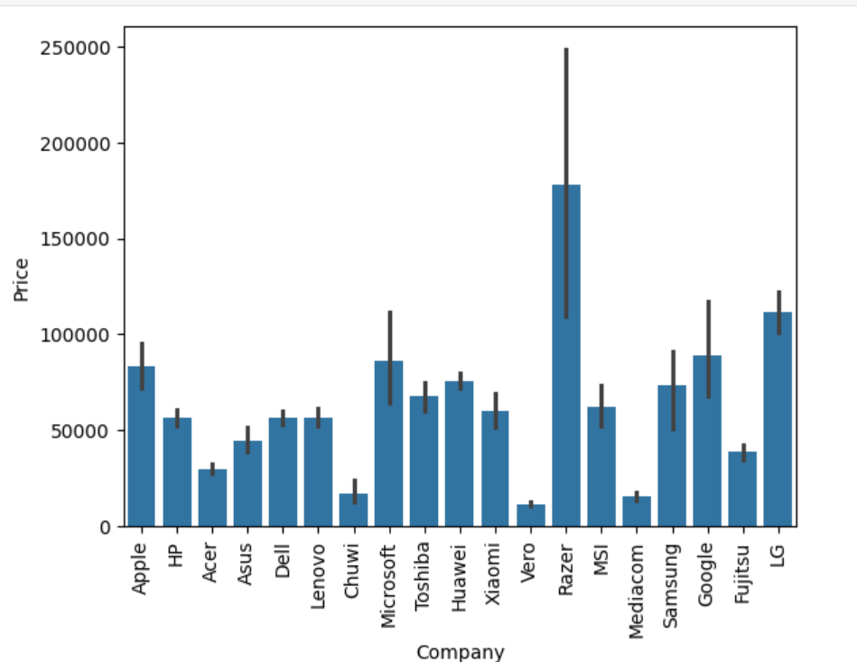

1. Number of different types of laptops

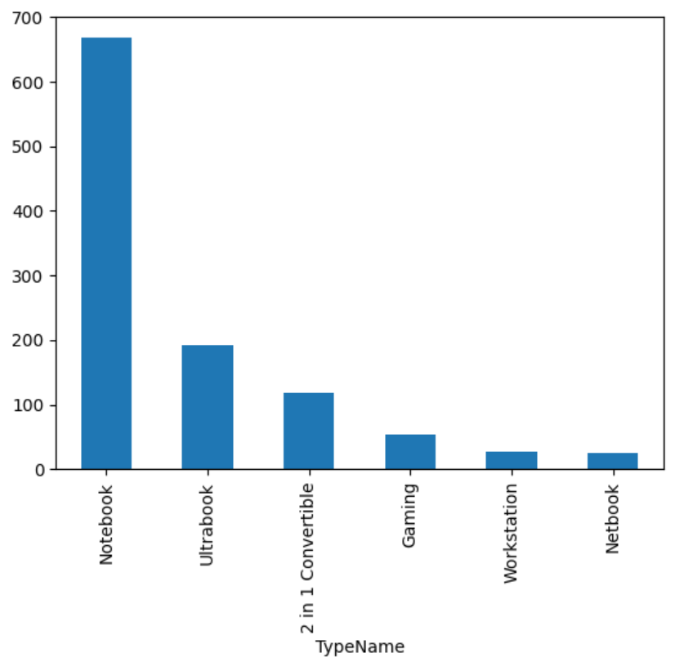

1. Average prices of each type of laptops

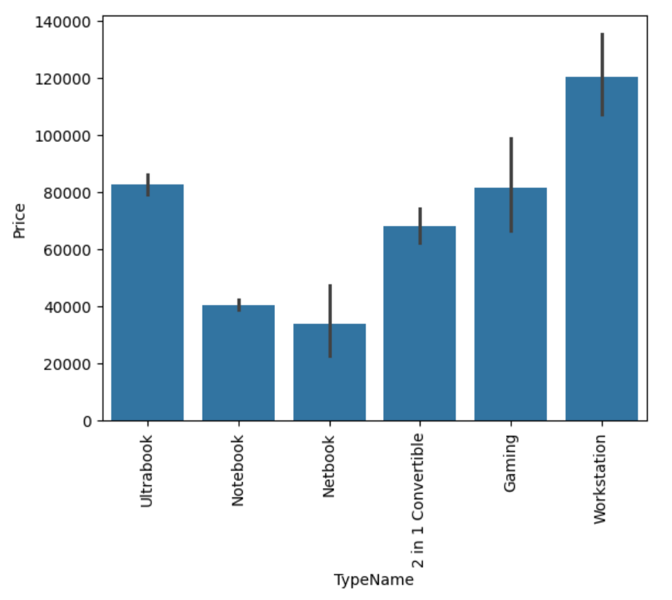

**MODEL SUMMARY**

In our laptop price prediction project, we utilized Linear Regression, Decision Tree and

Support Vector Machine algorithms. These methods were integrated into our price prediction pipeline

to process textual data and reduce dimensionality for improved efficiency. Through the synergistic

combination of these techniques, we achieved enhanced performance in generating accurate and

relevant price predictions.

1. The first model utilized in our laptop price prediction system is Linear Regression, a fundamental

technique in statistical modeling aimed at establishing a linear relationship between independent

variables and a target variable. In the context of our project, Linear Regression was employed to

analyze the relationship between various laptop features and their corresponding prices.

**This is the Final Result of Model:**

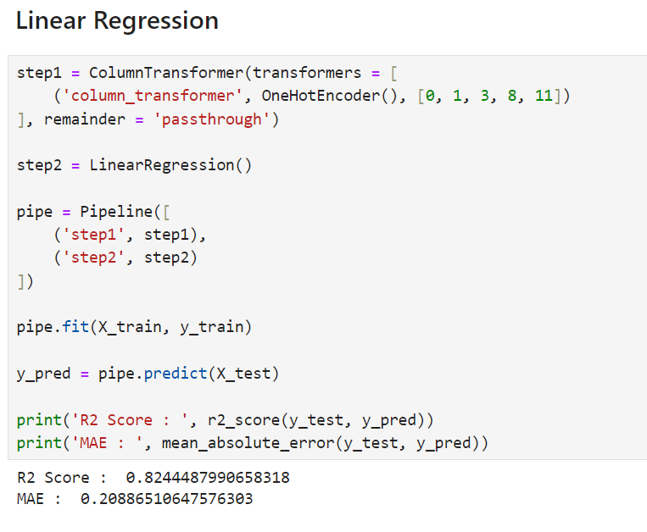

2. The second model utilized in our laptop price prediction system is Decision Tree, a powerful

machine learning algorithm that builds a tree-like structure to make decisions based on the features of the input data. In the context of our project, Decision Tree was employed to analyze the relationship between various laptop features and their corresponding prices.

**This is the Final Result of Model:**

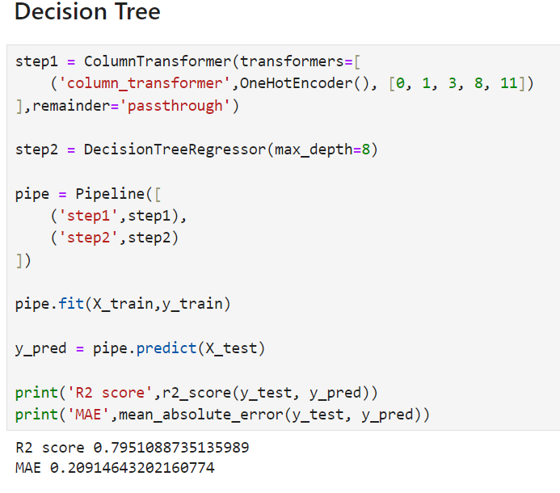

3. The third model employed in our laptop price prediction system is Support Vector Machine

(SVM), a powerful supervised learning algorithm used for classification and regression tasks. In

the context of our project, SVM was utilized for regression to predict the price of laptops based

on their features.

**This is the Final Result of Model:**

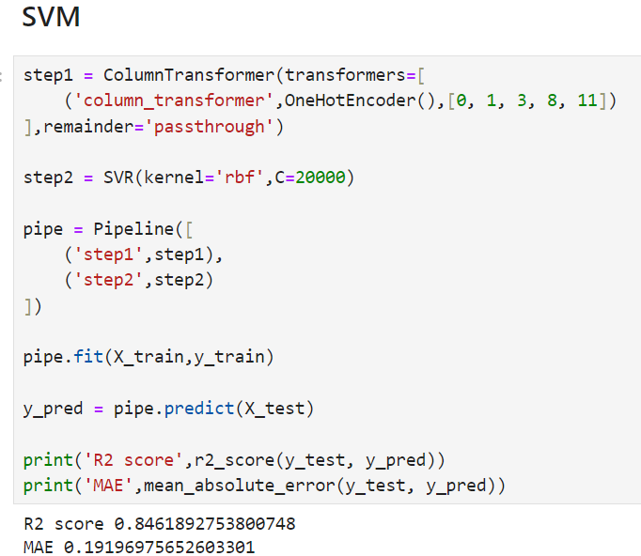

**CONCLUSION**

In conclusion, the implementation and evaluation of machine learning models for laptop price prediction represent a significant advancement in assisting consumers and stakeholders in making informed decisions within the computing technology market. Through the utilization of algorithms such as Linear Regression, Decision Tree, and Support Vector Machine (SVM), we have demonstrated the efficacy of predictive modeling in estimating laptop prices based on various features.

Our findings underscore the value of machine learning techniques in extracting insights from complex datasets and facilitating price estimation with a high degree of accuracy. By leveraging these algorithms, stakeholders can gain valuable insights into the factors driving laptop prices and make informed decisions regarding pricing strategies, purchasing decisions, and market positioning.

Moreover, the successful application of these models highlights the potential of artificial intelligence and machine learning in optimizing pricing dynamics within the laptop industry. By harnessing the power of predictive analytics, stakeholders can adapt to market trends, adjust pricing strategies in real-time, and enhance competitiveness in a rapidly evolving market landscape.

In summary, this project contributes to advancing predictive modeling methodologies in the domain of laptop pricing and underscores the transformative impact of artificial intelligence in enabling data-driven decision-making processes. As we continue to refine and expand upon these methodologies, we move closer to realizing the vision of a more transparent, efficient, and competitive laptop market that benefits consumers and industry stakeholders alike.